Administration of Medication Policy

Created by: Julie Armstrong
Date: October 2015

Date: | Policy reviewed: | Policy amended:
October 2020 |  | E Walker
October 2022
October 2024

Administration of Medication Policy

Introduction
There are an increasing number of children attending mainstream schools with medical conditions. Schools, acting in loco parentis, have a duty to take reasonable care of children which includes the possibility of having to administer medicines and/ or prescribed drugs. For pupils with long term medical needs this may be a regular occurrence, or for children with short term ailments this may be a one off event.
Newbuildings Primary School will make every effort to safeguard the health and safety of all pupils requiring any administration of medication.

Medical Register
At the start of every school year parents will be required to update medical information for their child/ children attending Newbuildings Primary School using a SIMS data collection form. This information will be collated by the Special Educational Needs Co-ordinator (SENCO) to form a medical register. This register will be shared with all members of staff, including teachers, classroom assistants, canteen staff and lunchtime supervisors to ensure that all staff are fully aware of any additional needs the children may have.
It is the responsibility of the parent to inform the school if any of the medical information changes throughout the school year.
School staff will review the register three times each year, once per term.

Children with additional medical needs
Newbuildings Primary School will ensure the health of safety of children with additional medical needs by completing the stages below;
- Consult the child’s parent/ guardian about the medical need. Information given will be collated into a care plan.
- Liaise with school nurse (Celine Ward) and check that the care plan requires all of the information required. Check if additional training is required for school staff e.g. administration of an epi-pen.
- The care plan will contain a recent colour photograph of the child.
- Completed care plans will be signed by the parent.
- Care plans will be displayed in the classroom, school office and school canteen (if necessary).

If a child has an additional need which may require medication Appendix A (Consent for Medication) will be fully completed. A copy will be kept by the parent, class teacher and in the school medical file.
Any medications e.g. piriton will be stored in a named container, out of the reach of children, but not locked away.

Children with short term ailments
Parents must keep their children at home if acutely unwell or infectious. Newbuildings Primary School will follow the infection guidelines outlined by the Department of Health. If in any doubt advice should be sought from the school nurse.
If a child requires medication for a short term period e.g. Calpol for a cold, an antibiotic for an infection, the parent must fully complete Appendix A and return to the class teacher.
The parent should provide the class teacher with the following;
- Prescribed medication in the correct container and with full instructions. The container must be clearly labelled by with the child’s name.
- Clear instructions regarding the administration (e.g. dose of medication and frequency).
- Any equipment required to administer the medication e.g. spoon, syringe.
Only reasonable quantities of medication should be supplied to the school (for example, a maximum of four weeks supply at any one time).
Only the prescribed dose will be administered. This cannot be changed unless written instructions are given from a medical professional.
If a child is given any medication in school the record-keeping sheet will be completed in the teacher log books.(Appendix B)
Please note that staff are not obliged to provide any child with medication- this is solely at the discretion of the class teacher. If a class teacher does not wish to administer medication responsibility will the lie with the school principal.

Asthma Register
Information provided by parents at the start of the school year will be collated by the Special Educational Needs Co-ordinator (SENCO) to devise an asthma register. The SENCO will update/amend the school’s asthma register using the information provided by parents on the SIMS data collection form. It is vital that parents fill out this form correctly at the start of every academic year. The school will not be held liable for information shared on this form by parents.
The asthma register will be shared with all members of staff, including teachers, classroom assistants, canteen staff and lunchtime supervisors to ensure that all staff are fully aware of any additional needs the children may have. The register will be displayed in the school office.
School staff will review the register three times each year, once per term.
Children on the asthma register will be sent home a consent form (Appendix C) and parents will also be asked to complete an asthma care plan (Appendix E) when their child is first diagnosed with asthma. These forms will confirm the diagnosis of asthma, provide details of triggers, what steps to take if a child is having an asthma attack, gives permission for them to use their inhaler if required and also allows access to our asthma kit, in the event of an emergency.
Appendix E will be updated and amended if necessary at the beginning of each new academic school year, unless additional information is provided by a parent/guardian during the course of a school year.
If a child requires the use of their inhaler Appendix D will be sent home to parents, on the day of use.
Children will be supervised by their class teacher if using their inhaler.
Inhalers will be stored in a central box in the classroom, out of the reach of children, but not locked away.

Newbuildings Primary School Appendix A

REQUEST FOR A SCHOOL TO ADMINISTER MEDICATION

The school will not give your child medicine unless you complete and sign this form, and the Principal has agreed that school staff can administer the medicine

Details of Pupil
Surname Forename(s)
Address

Date of Birth / / M F
Class
Condition or illness

Medication
Parents must ensure that in date properly labelled medication is supplied.
Name/Type of Medication (as described on the container)

Date dispensed

Expiry Date

Full Directions for use:
Dosage and method

NB Dosage can only be changed on a Doctor’s instructions

Timing
Special precautions
Are there any side effects that theSchool needs to know about?

Self-Administration Yes/No (delete as appropriate
Procedures to take in an Emergency
Appendix A

Contact Details
Name
Phone No: (home/mobile)
(work)

Relationship to Pupil
Address

I understand that I must deliver the medicine personally to
(agreed member of staff) and accept that this is a service, which the school is not obliged to undertake. I understand that I must notify the school of any changes in writing.

Signature(s) Date

Agreement of Principal
I agree that (name of child) will receive (quantity and name of medicine) every day at ____________________ (time(s) medicine to be administered e.g. lunchtime or afternoon break).

This child will be given/supervised whilst he/she takes their medication by
(name of staff member)
This arrangement will continue until (either end
date of course of medicine or until instructed by parents)

Signed Date
(The Principal/authorised member of staff)

The original should be retained on the school file and a copy sent to the parents to confirm the school’s agreement to administer medication to the named pupil.

Newbuildings Primary School
Appendix B

Record of medicine administered
to an individual child

Surname
Forename (s)
Date of Birth | ___ /____ / ___ M F
Class
Condition or illness
Date medicine provided by parent
Name and strength of medicine
Quantity received
Expiry date | ____ / ____ / ____
Quantity returned
Dose and frequency of medicine

Checked by:

Staff signature Signature of parent

Date | ___ / ___ / ___ | ___ / ___ / ___ | ___ / ___ / ___
Time given
Dose given
Any reactions
Name of member of staff
Staff initials

Date | ___ / ___ / ___ | ___ / ___ / ___ | ___ / ___ / ___
Time given
Dose given
Any reactions
Name of member of staff
Staff initials

Appendix B (Continued)

Date | ___ / ___ / ___ | ___ / ___ / ___ | ___ / ___ / ___
Time given
Dose given
Any reactions
Name of member of staff
Staff initials

Date | ___ / ___ / ___ | ___ / ___ / ___ | ___ / ___ / ___
Time given
Dose given
Any reactions
Name of member of staff
Staff initials

Date | ___ / ___ / ___ | ___ / ___ / ___ | ___ / ___ / ___
Time given
Dose given
Any reactions
Name of member of staff
Staff initials

Date | ___ / ___ / ___ | ___ / ___ / ___ | ___ / ___ / ___
Time given
Dose given
Any reactions
Name of member of staff
Staff initials

Consent Form-
Appendix C
Use of inhalers in Newbuildings Primary School

Children showing symptoms of asthma/having asthma attack

- I can confirm that my child has been diagnosed with asthma.
- My child has been provided with an inhaler by their GP/ asthma clinic.
- I will provide my child’s class teacher with a working, in-date inhaler and spacer (if necessary), clearly labelled with my child’s name.
- In the event of my child showing signs of asthma I give permission for them to use their inhaler, supervised by a member of staff.
- In the event of an emergency, or if my child’s inhaler is unusable or not available, I give consent for my child to receive salbutamol from an emergency inhaler held by the school for such emergencies.
- It is my responsibility to inform the school if there is any change in my child’s diagnosis.

Name of child-

Class-

Name of parent-

Parent signature-

Comments (if necessary)-

Record Keeping: Use of an inhaler at Newbuildings Primary School
Appendix D

Child’s name-
Class-
Date-

Dear Parent/ Guardian,

Your child experienced symptoms of asthma in school today. They required the use of an inhaler.

Time-
Activity-
Symptoms noted-
Supervised by-

Your child used;
Their own inhaler

School’s emergency inhaler

Number of puffs given-

Additional comments-

Yours sincerely,

____________________

Appendix E My Asthma Care Plan
Place child’s photo here
Name of Child: ____________________________________________
Class: _________________________________________
2. When my asthma gets worse
I’ll know my asthma is getting worse if:
- I wheeze or cough, my chest hurts or it’s hard to breathe, or
- I’m waking up at night because of my asthma, or
- I’m taking my reliever inhaler (usually blue) more than 3 times a week, or
- My peak flow is less than __________
- My usual asthma medicines
- My preventer inhaler is called ________ and its colour is _________________.

- I take ________________ puff/s of my preventer inhaler in the morning and _____________puff/s at night. I do every day even if I feel well.

- Other asthma medicines I take every day:
________________________________

- My reliever inhaler is called _______________ and its colour is ________________________.
I take _________puff/s of my reliever inhaler (usually blue) when I wheeze or cough, my chest hurts or it’s hard to breathe.

- My best peak flow is ________________

1

If my asthma gets worse, I should:
Keep taking my preventer medicines as normal.
And also take ____________ puff/s of my blue reliever inhaler every four hours.
lf l'rn not getting any better doing this I should see rny doctor or asthrna nurse today.

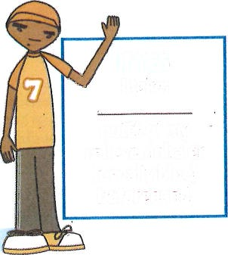
Does doing sport moke it hard to breathe?
If YES
I take __________
puff/s of my reliever inhaler (usually blue) beforehand.

Remember to use my inhaler with a spacer (if I have one)

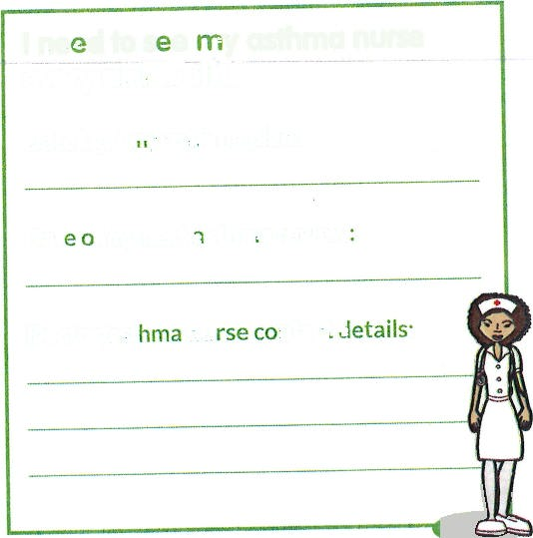
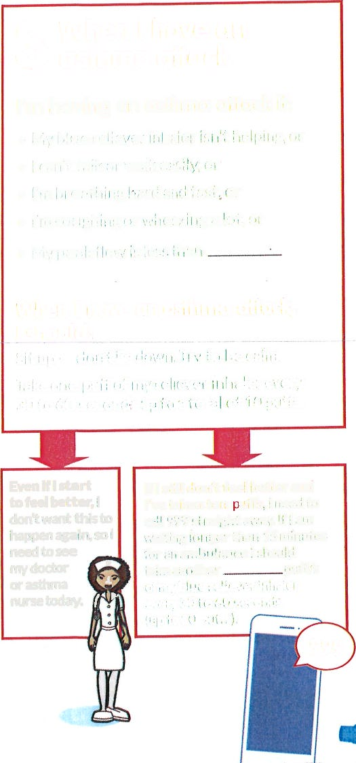
Date of my next asthma review:
_____________________
Doctor/asthma nurse contact details
__________________________
__________________________
I need to see my asthma nurse every six months
Date I got my asthma plan:
___________________________
Contact Numbers in an emergency – always dial 999 first:
Priority 1____________________________________
Priority 2 ___________________________________
Even if I start
to feel better, I don't want tlhis to happen again, so I need to see
my doctor + or asthma I nursetoday. ( '
lf I still don't feel better and I've taken ten puff5, school/home needs to call 999 striaght away. lf I am waiting Ionger than 15 minutes for an arnbulane I should
take another________ puff/s of my blue reliever inhaler every 30 to 60 seconds (up to 10 puffs)
Always keep your reliever
inhaler (usually blue) and
your spacer with you.
You might need
them if your
asthma
gets worse.
My asthma triggers:
List the things that make your asthma
worse and what you can do to help
a

3. When I have an asthma attack
I’m having an asthma attack if:
- My blue reliever inhaler isn’t helping, or
- I can’t talk or walk easily, or
- I’m breathing hard and fast, or
- I’m coughing or wheezing a lot, or
- My peak flow is less than ____
When I have an asthma attack, I should:
Sit up – don’t lie down. Try to be calm.
Take one puff of my reliever inhaler every 30 to 60 seconds up to a total of 10 puffs.

